Payroll App

## Instructions

Instructions for “Payroll App”

**Please read and follow all the instructions for a proper use of application!**

## Pre-requisites:

1. TB template – should be made on the template presented down below:



In the TB Template, map the information from the Trial Balance provided by the client, onto the Template shown here accordingly. (Account, Description, Opening Balance, Movement Debit & Credit, Closing Balance.) In the RDC and RCC fields, please fill the monthly debit (RDC) and monthly credit (RCC) amounts from trial balance for December month.

|  |  |  |  |  |  |  |  |
| --- | --- | --- | --- | --- | --- | --- | --- |
| Account | Description | OB | DM | CM | CB | RDC | RCC |
|  |  |  |  |  |  |  |  |

1. Import D112 –The XML files can be downloaded from the D112.pdf documents, as shown below:

After opening an PDF document, click on the clip on the left side:

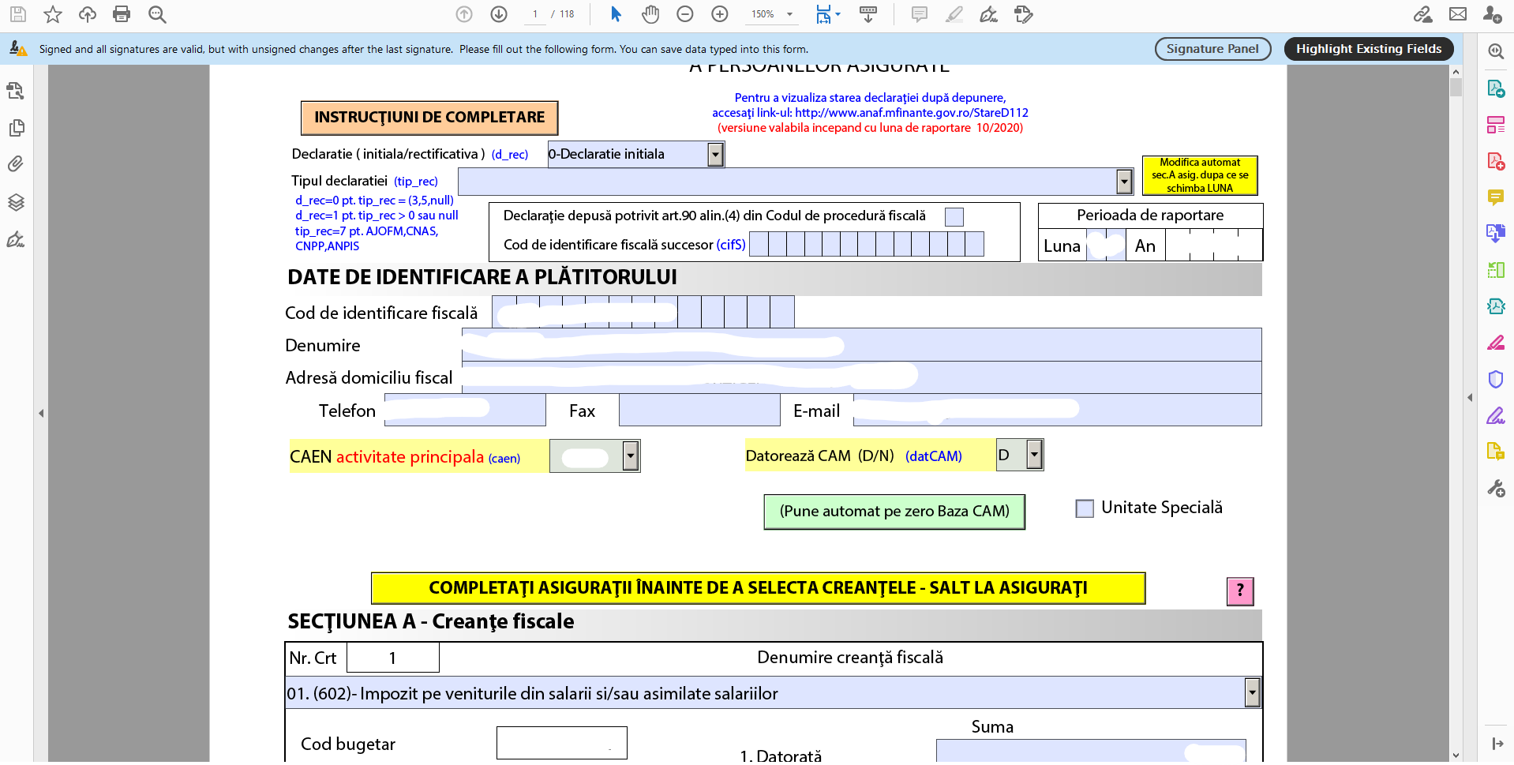

After, right-click on the XML document and save it in your desired location:

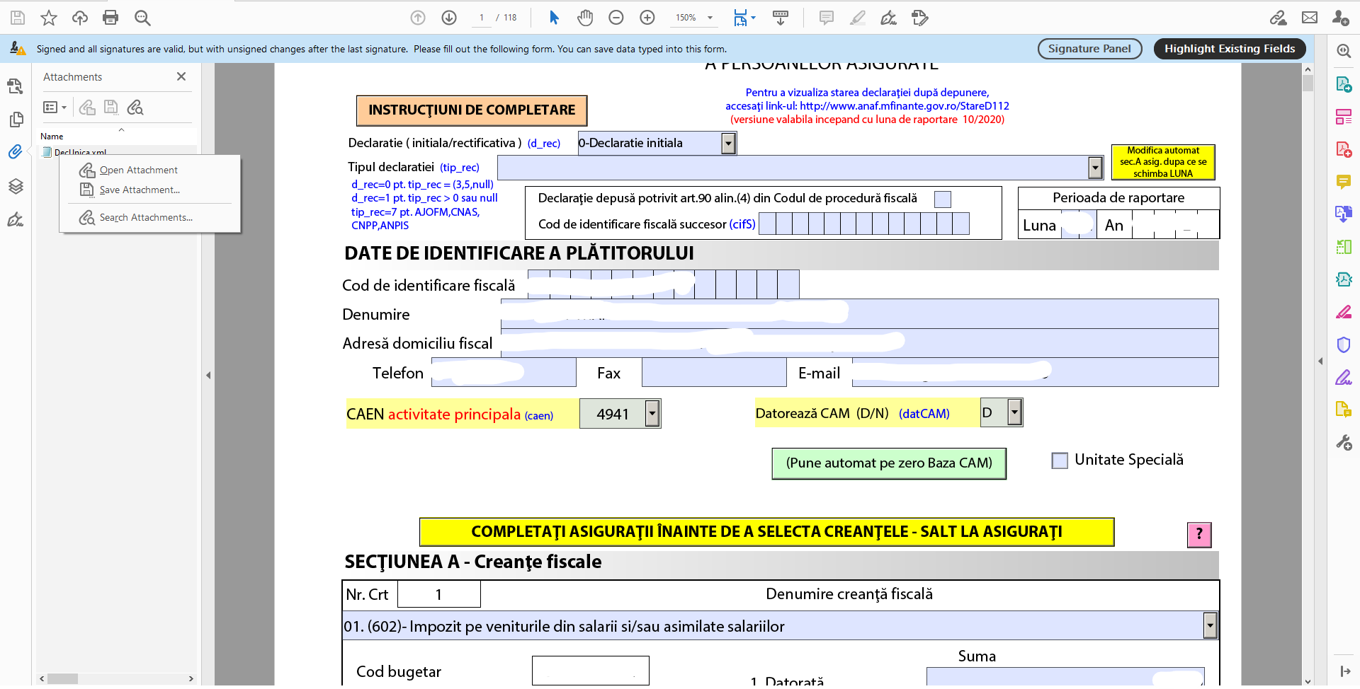

1. PBC template should not be modified by the user, and can be found down below:



1. Monthly P&L template should not be modified by the user(even the sheets name), and can be found down below:



Good to know: even if you don’t have the information for all months, it is mandatory that you should write in the header all months. So for example, if you have the information from January to October (ex: at interim), you have also to write the in the header the rest of the months, even if the columns will be empty.

## Instructions:

1. While connected to VPN, access the server at <http://192.168.1.222:5000/> and select de Payroll webapp from portal:

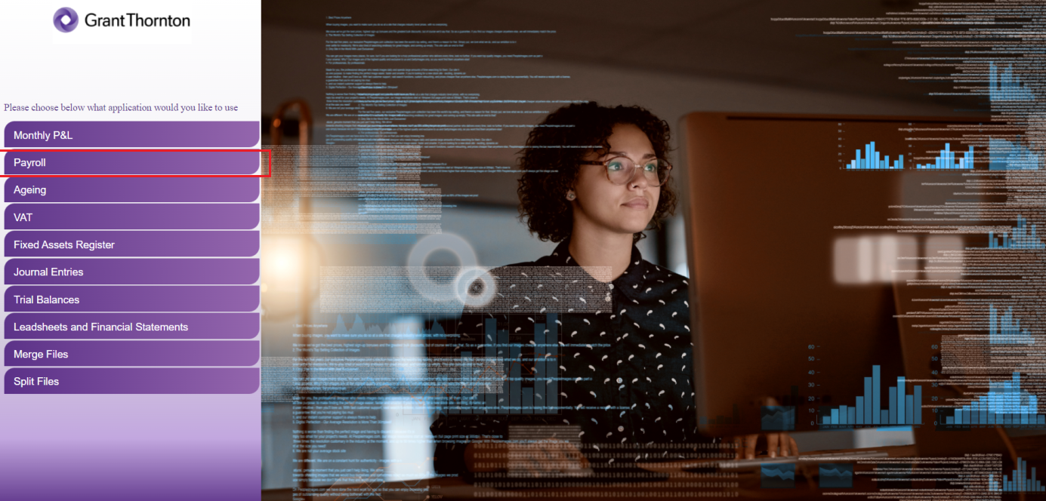

1. In the next page shown below, please enter de details as it follows:

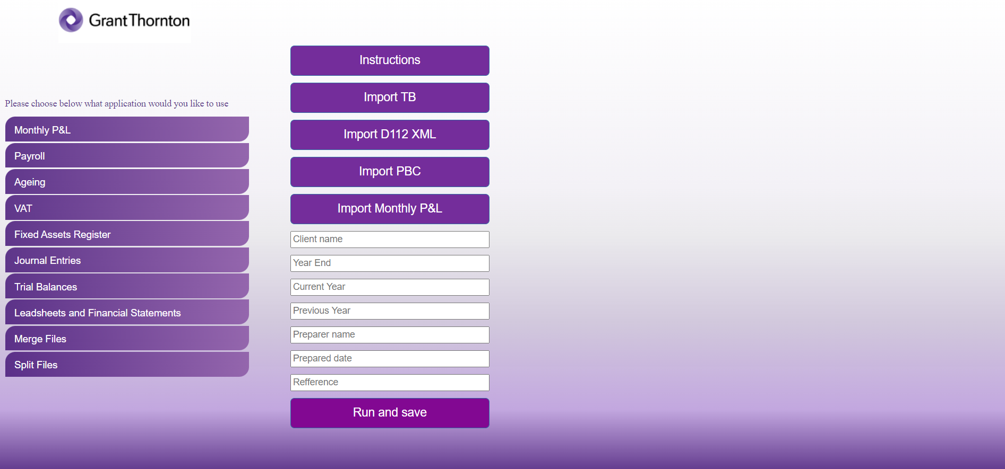

1. Enter the client’s name, the period end (MM/DD/YYYY) of the audit, the current and previous year and the preparer’s name and the preparing date .
2. Click “Import TB” and import the Trial Balance template.
3. Click “Import D112” and import the XML file.
4. Click “Import PBC” and import the PBC template completed accordingly.
5. Click “Import Monthly P&L” and import the monthly P&L data for the current and previous year.
6. Click “Run and save”. Once clicking that, the robot will ask the desired saving location, will process your request and exit the application, then announce you if the process succeeded.
7. Finally, you should obtain an Excel document named “V10 Payroll Analysis” + the name of the client.

Please keep in mind that a connection to VPN is required in order to use the web applications.

Note: Please do not modify any of the templates provided.

For any issues, questions and/or suggestions, please contact:

Cristian Iordache, [cristian.iordache@ro.gt.com](mailto:cristian.iordache@ro.gt.com)